## <http://www.slsmk.com/setup-syslog-with-loganalyzer-on-ubuntu-server/>

## Setup Syslog on Ubuntu Server

This article will cover:  
1) Setting up a syslog server to log messages from local and remote sources.  
2) Setup a GUI front end showing syslog items.

I’ve done this on both Ubuntu Server 10.04 and 12.04.

1. Get some items loaded from the repository.

# *apt-get install build-essential apache2 php5 php5-gd libapache2-mod-php5 mysql-server php5-mysql rsyslog*

1. Edit */etc/rsyslog.conf* and uncomment or add the following. This will set the server to accept inbound syslog messages on UDP port 514.

### rsyslog: Enabling remote logging service in Ubuntu

Newer versions of Ubuntu (since 9.10 according to rsyslog wiki: <http://wiki.rsyslog.com/index.php/Ubuntu>) comes with *rsyslog* instead of *sysklogd*. That obviously didn't work, while trying to enable it via the sysklogd way by adding the "-r" option in the startup script.   
What you'll need to do is just uncomment 2 lines in the /etc/rsyslog.conf file. This will set the server to accept inbound syslog messages on UDP port 514

*# provides UDP syslog reception  
$ModLoad imudp  
$UDPServerRun 514*

That's if you want to provide UDP syslog service. Uncomment the following 2 lines if you want to provide TCP syslog service:

*# provides TCP syslog reception  
$ModLoad imtcp  
$InputTCPServerRun 514*

Once you've made the changes, either reload or restart the rsyslogd service:

myhost:/etc# /etc/init.d/rsyslog reload  
Reloading enhanced syslogd: rsyslogd.

I've chose to enable UDP for my server.  We'll use netstat to check if rsyslogd is listening to the specified port:

myhost:/etc*# netstat -tlnup | grep 514*  
udp        0      0 0.0.0.0:514             0.0.0.0:*                           13282/rsyslogd  
udp6       0      0 :::514                  :::*                                13282/rsyslogd

*rsyslogd* is indeed listening to the proper port and protocol.

1. Since the log analyzer runs on php, we need to tell apache how to handle php pages. Edit */etc/apache2/apache2.conf* and add in the following item underneath “DefaultType None”

*DefaultType text/plain*

*Addtype application/x-httpd-php .php*

Note: If this step is not done properly, you will get a message when loading the syslog web page prompting you to save the file instead of Apache displaying the file.

Note: Restart the web server after you made configuration change like: # */etc/init.d/apache2 restart*.

**On to the LogAnalyzer**.  
1. Download the latest log analyzer from the adiscon web site at http://loganalyzer.adiscon.com/downloads

cd /opt

wget http://download.adiscon.com/loganalyzer/loganalyzer-3.6.2.tar.gz

2. Unzip and extract the file.

gunzip loganalyzer-3.6.2.tar.gz

tar -xvf loganalyzer-3.6.2.tar

1. Copy the LogAnalyzer /src/ folder to the Apache www root or subfolder, copy the install script, make executable, and run the install scripts. It’s important to run the configure script from the same directory that will hold the syslog php files.

*mkdir /var/www/syslog*

*cp -r /opt/loganalyzer-3.6.2/src/* /var/www/syslog*

*cp -r /opt/loganalyzer-3.6.2/contrib/*.sh /var/www/syslog*

*chmod +x /var/www/syslog/*.sh*

*cd /var/www/syslog/*

*./configure.sh*

1. Grant Apache access to syslog.

usermod -G adm www-data

Use a web browser to hit the new web service at [*http://SERVERNAME/syslog/index.php*](http://SERVERNAME/syslog/index.php) (Ex: <http://localhost/syslog/index.php>). The page will show a message stating the service is not configured. Follow the steps to setup your syslog front end.

## Go to <http://140.111.74.38/blog/post/2/632> to see the detailed information about how to initialize LogAnalyzer.

## <http://linadonis.pixnet.net/blog/post/27585552-ubuntu-server-%E5%AE%89%E8%A3%9D-phpmyadmin>

## [Ubuntu Server 安裝 Phpmyadmin](http://linadonis.pixnet.net/blog/post/27585552)

* 1.安裝套件
* #sudo apt-get install phpmyadmin

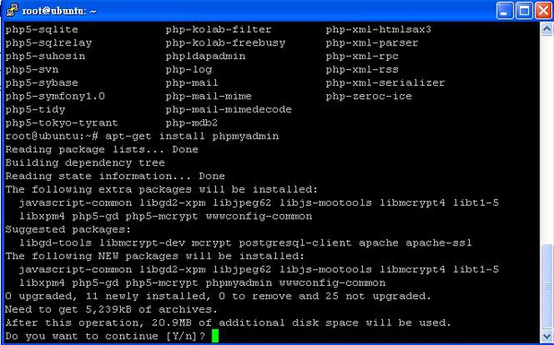

* 2.點選Yes

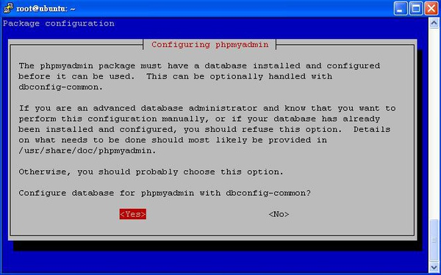

* 3.輸入管理者登入帳號

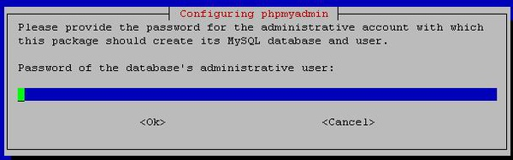

* 4.輸入管理者的密碼

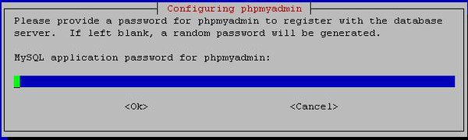

* 5.在輸入一次密碼

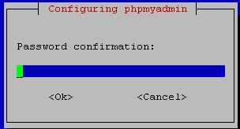

* 6.選擇[apach2]

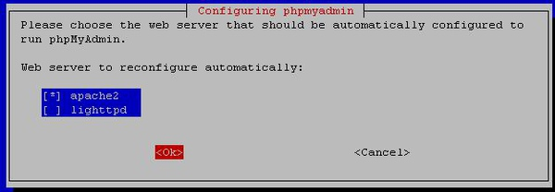

* 7.完成後開啟流覽器輸入[http://127.0.0.1/phpmyadmin/]

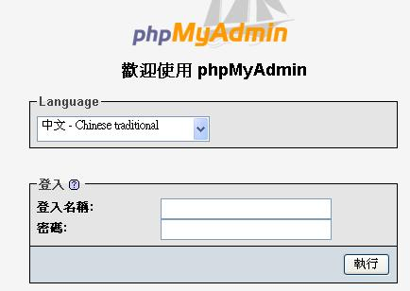

* PS:若在連結時出現

# Not Found

* The requested URL /phpmyadmin/ was not found on this server.  
  解決方法:  
  #cd /var/www  
  #ln -s /usr/share/phpmyadmin  
  完成

說到MySQL的管理工具，腦裡就浮現了phpMyAdmin，這應該是被拿來管理MySQL的最常用工具了，但其實MySQL本身就有提供蠻好用的管理程式：mysqladmin.exe，但因為是命令列互動式，最後大家還是會選擇有UI介面的，畢竟操作方面才是最重要的。  
其實不管是哪個資料庫都會提供這類指令互動程式來操作資料庫，因為資訊保密的重要，最後常常要面對的環境就是一個console介面而已，平常的練習和熟悉指令看來還是必須的。實際來操作一遍mysqladmin.exe。  
打開一個DOS視窗後，切換到存放MySQL應用程式的資料夾。  
以下粗體為實際指令，{}包起來的內容是說明。  
D:\WebServer\mysql\bin>**mysql -h 127.0.0.1 -u root -p** (本行指令：應用程式名稱、指定伺服器、伺服器名稱/網紙、指定使用者、使用者名稱、指定資料庫)  
Enter password:  
Welcome to the MySQL monitor. Commands end with ; or \g.  
Your MySQL connection id is 1  
Server version: 5.5.14-log MySQL Community Server (GPL)  
  
Copyright (c) 2000, 2010, Oracle and/or its affiliates. All rights reserved.  
  
Oracle is a registered trademark of Oracle Corporation and/or its  
affiliates. Other names may be trademarks of their respective  
owners.  
  
Type 'help;' or '\h' for help. Type '\c' to clear the current input statement.  
(進入管理模式，下列所有指令後面需以;結尾)  
mysql> **show databases;** {察看目前擁有的資料庫清單}  
+--------------------+  
| Database |  
+--------------------+  
| information_schema |  
| mysql |  
| performance_schema |  
| test |  
+--------------------+  
4 rows in set (0.08 sec)  
  
mysql> **Select user();** {顯示目前擁有的使用者清單}  
+----------------+  
| user() |  
+----------------+  
| root@localhost |  
+----------------+  
1 row in set (0.03 sec)  
  
mysql> **use test;** {選擇要進行操作的資料庫}  
Database changed  
mysql> **show tables;** {顯示資料庫test的資料表清單}  
Empty set (0.06 sec)  
  
mysql> **create table UsrData (  
-> Id int,  
-> FirstName varchar(20),  
-> LastName varchar(20));** {建立一個資料表}  
Query OK, 0 rows affected (0.11 sec)  
  
mysql> **show tables;**  
+----------------+  
| Tables_in_test |  
+----------------+  
| usrdata |  
+----------------+  
1 row in set (0.00 sec)  
  
mysql> **desc usrdata;** {檢視資料表usrdata的欄位定義}  
+-----------+-------------+------+-----+---------+-------+  
| Field | Type | Null | Key | Default | Extra |  
+-----------+-------------+------+-----+---------+-------+  
| Id | int(11) | YES | | NULL | |  
| FirstName | varchar(20) | YES | | NULL | |  
| LastName | varchar(20) | YES | | NULL | |  
+-----------+-------------+------+-----+---------+-------+  
3 rows in set (0.06 sec)  
  
mysql> **insert into usrdata (Id, FirstName, LastName)  
-> values (0, 'Java', 'Sun');**  
Query OK, 1 row affected (0.03 sec)  
  
mysql> **insert into usrdata (Id, firstname, lastname)  
-> values (1, 'java', 'oracle');**  
Query OK, 1 row affected (0.01 sec)  
  
mysql> **select * from usrdata;**  
+------+-----------+----------+  
| Id | FirstName | LastName |  
+------+-----------+----------+  
| 0 | Java | Sun |  
| 1 | java | oracle |  
+------+-----------+----------+  
2 rows in set (0.03 sec)  
  
mysql> **select firstname, lastname from usrdata;**  
+-----------+----------+  
| firstname | lastname |  
+-----------+----------+  
| Java | Sun |  
| java | oracle |  
+-----------+----------+  
2 rows in set (0.00 sec)  
  
mysql> **quit;** {離開}  
Bye

*Install MySQLDB so that Django can access MySQL.*

*1. sudo apt-get install libmysqld-dev*

*2. sudo apt-get install python-dev*

*3. Download MySQL-python-1.2.4b4.tar.gz*

*1) python setup.py build*

*2) sudo python setup.py install*